Expression of Interest
Town Centre Property Improvement Grant (TCPIG) – 2026-2027 Scheme
Complete all sections marked with *. This form should take approximately 15 – 20 minutes to complete. Once submitted, we will assess your eligibility and contact you within 10 working days.

A. Applicant & Contact Details
Applicant name *
Organisation type * | -- Select --
If other, please specify
Primary contact name *
Email address *
Telephone number *
Correspondence address *
Enter full address including postcode

B. Property Details
Property address *
Enter full address including postcode
Is the property within TCPIG town centre boundaries? *  Boundary maps are available here:  Buckley | Connah’s Quay | Flint | Holywell | Mold | Queensferry | Saltney | Shotton | -- Select --
Current property status * | -- Select --
If other, please specify
Property use * | -- Select --
If other, please specify
Ownership status * | -- Select --
Landlord consent secured?  Required if leaseholder or lease planned. | -- Select --
Supporting detail.
Completion date / lease years remaining / lease start date / other detail as applicable

C. Project Summary
Brief description of proposed works *
Maximum 300 words. Describe what you want to do, why, and what it will achieve.

Primary objective(s) *  Select all that genuinely apply. What does your project primarily aim to achieve? | ☐ Refurbish or improve an existing commercial property  Physically improve the condition, appearance or function of an existing commercial building — external works, internal refurbishment, or both.  ☐ Bring a vacant commercial property back into use  A property currently empty or not in active commercial use will be returned to active occupation following the works.  ☐ Create new commercial units or floor space  New lettable commercial units will be created, or total commercial floor space will increase — through extension, conversion or subdivision.  ☐ Create or safeguard jobs  The project will result in new jobs being created or will protect existing jobs that would be at risk without the works.  ☐ Support an existing business to operate or grow  Works will directly enable a business to trade, expand, or improve its offering — without necessarily creating new units or measurable new jobs.  ☐ Improve energy efficiency of the property  At least one element of the works directly reduces energy consumption or improves the thermal performance of the building.  ☐ Support Welsh businesses through local procurement  Welsh-based SMEs will be appointed as contractors or sub-contractors for the works — keeping grant investment in the Welsh economy.  ☐ Other objective (please describe in the field below)
If other objective, please specify

D. Costs, Funding & Readiness

Grant range: £5,000–£50,000 and up to 70% of total project costs. You must provide a minimum 30% contribution. Grants are paid out retrospectively; however, interim claims throughout the project are encouraged to help support applicants’ cash flow, with the final claim submitted once works are completed.

Estimated total project cost (£) *
Inclusive of VAT where applicable.
Grant funding sought (£) *
Must not exceed 70% of total project cost and stay in a range of £5,000 - £50,000.
Applicant funding source(s) *  Select all that apply. | ☐ Private finance  ☐ Personal funds  ☐ Loan  ☐ Other public funding (please specify below)  ☐ Other (please specify below)
If other, please specify
Have you obtained quotes or cost estimates? * | -- Select --

E. Consents & Delivery

Not sure if you need planning permission? Visit Planning Permission Advice for details.
Not sure if you need building regulations approval? Visit Building Regulation Approval for details.
If your property is listed or in a conservation area (see Map of conservation areas or look at maps below), we encourage you to arrange Pre-application Planning Advice site visit with our Conservation Officer before submitting the form:
- Listed Building Advice details
- Conservation Area Advice details

Conservation area Flint | Conservation area Holywell | Conservation area Mold
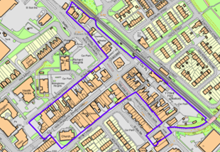 | 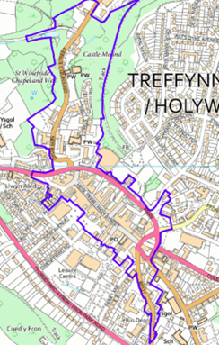 | 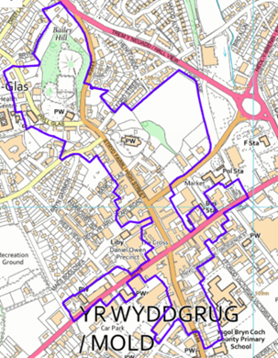

Planning status * | -- Select --
Planning application reference
If submitted or approved.
Building regulations status * | -- Select --
Building regulations reference
If submitted or approved.
Is the property listed or in a conservation area? * | -- Select --

Target start date *
Approximate month and year, e.g. June 2026
Target completion date *
Works must be completed within the grant offer period – not later than January 2027.

F. Declarations

Public Funding Declaration (Subsidy Control)
To comply with subsidy control rules, please declare any public funding or grants received in the last 3 financial years.

Previous public funding * | -- Select --

If you have received public funding, please provide details for each award:
Funding body | Scheme / grant name | Amount (£) | Date awarded

I declare that:
- The information provided in this Expression of Interest is true, complete and accurate to the best of my knowledge and belief.
- I am authorised to submit this Expression of Interest on behalf of the applicant organisation or property owner.
Full name *
Job title / role
If submitting on behalf of an organisation.
Date *

Data Protection Statement
Flintshire County Council will process personal and organisational data provided in this form for the purposes of administering, assessing, monitoring and auditing the Town Centre Property Improvement Grant. Data will be processed in accordance with the UK GDPR and Data Protection Act 2018.

Data protection consent * | ☐ I consent to Flintshire County Council processing the information provided for the purposes of administering this grant scheme.
Privacy Notice * | ☐ I confirm that I have read the Council's Privacy Notice.

